**PhonePe INTEGRATION**

**PhonePe API documentation** [**https://developer.phonepe.com/v1/reference/pay-api/**](https://developer.phonepe.com/v1/reference/pay-api/)

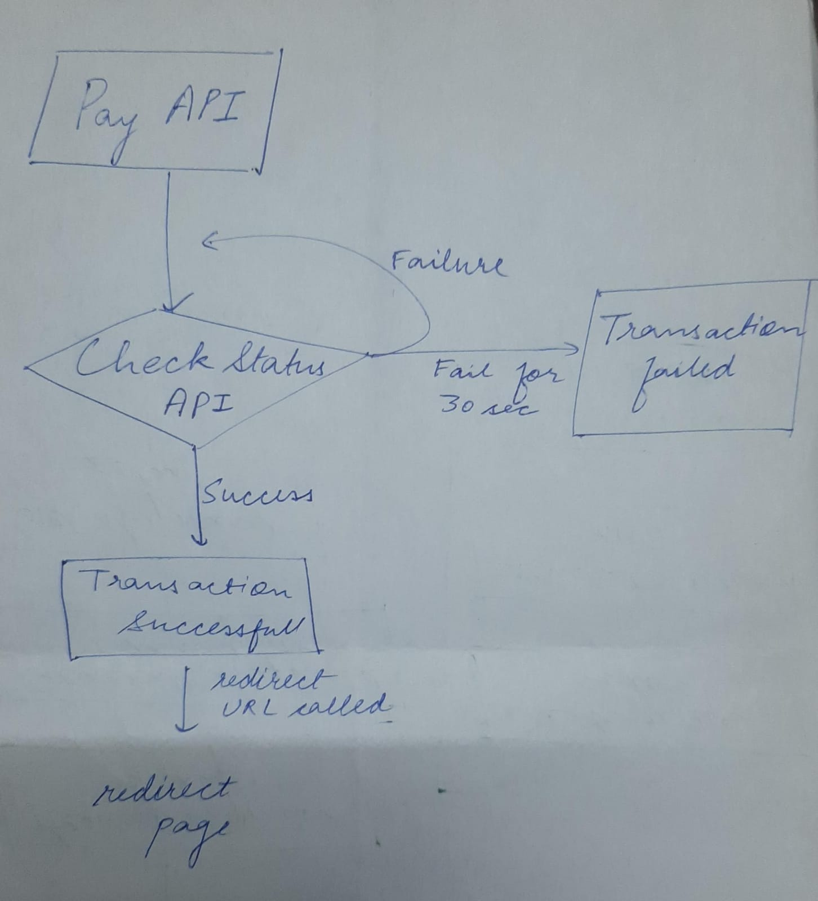

**SHIPROCKET INTEGRATION**

**Shiprocket API documentation** <https://apidocs.shiprocket.in/>

API call flow-

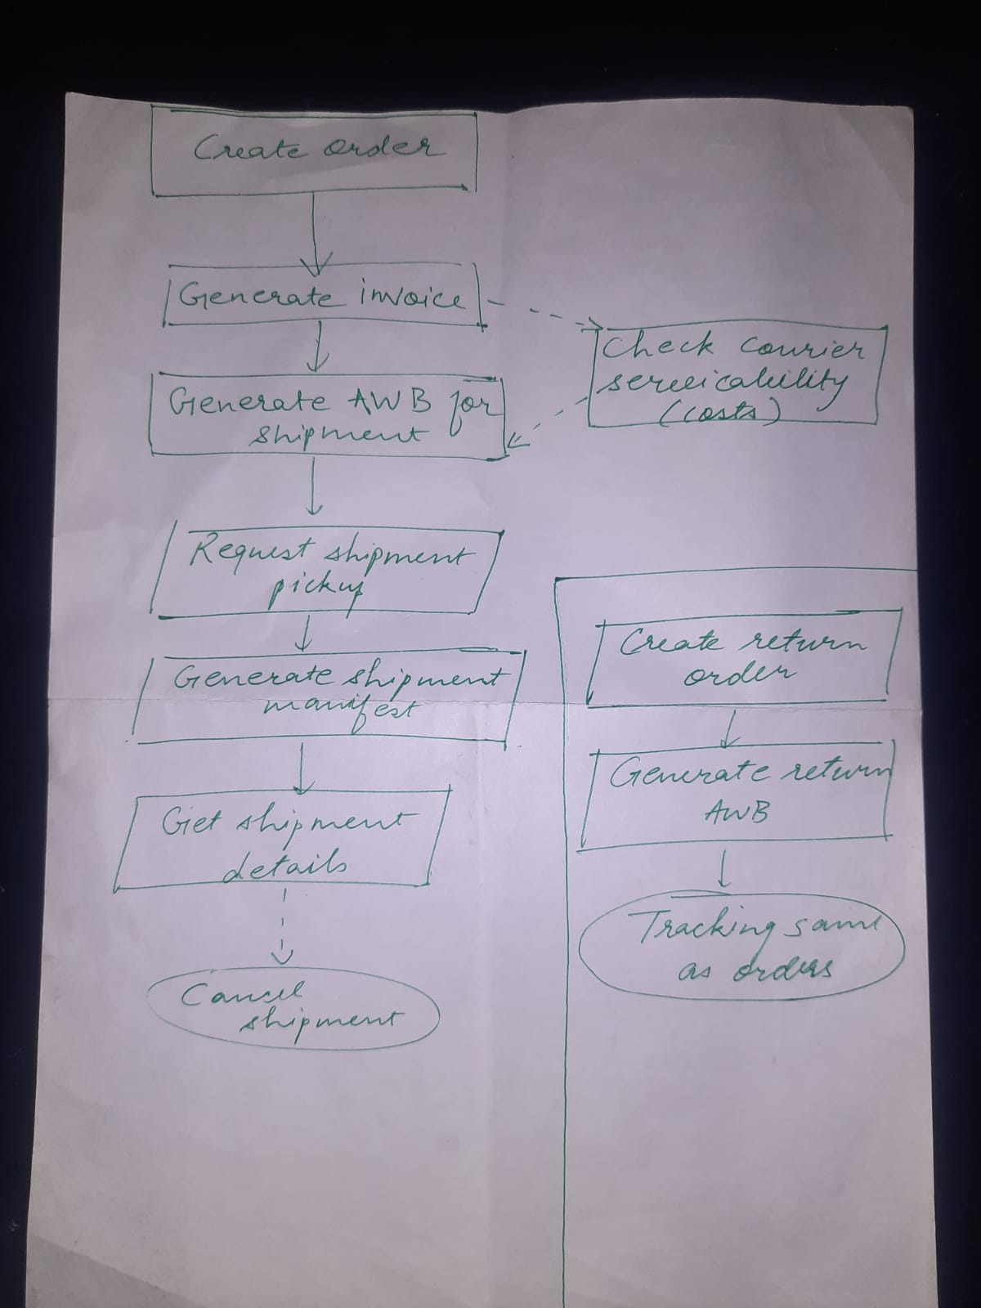

**Request and response fields of importance for the above APIs-**

1. **Check Serviceability API (POST)**

**Function-**The API gives details of

* Courier services available to deliver from source to destination.
* The costing (rate, freight charges etc. of these services.
* The names and other key details of the courier services

**Initial call-**First called after confirmation of the delivery address and before checkout, *shiprocket account set to minimum delivery cost setting* sets the cost same as the service that has the minimum *“rate”* this rate is *added to the cart total just before checkout*.

**Request fields added-**

* **shipping_postcode (number)** - The postal code of the shipping destination.
* **weight (number)** - The weight of the shipment.
* **declared_value (number)** - The declared value of the shipment.
* **is_return (number)** - Indicates whether the shipment is a return (0 for no, 1 for yes).

**Response-** Array of JSON objects each having details of the different courier services available.

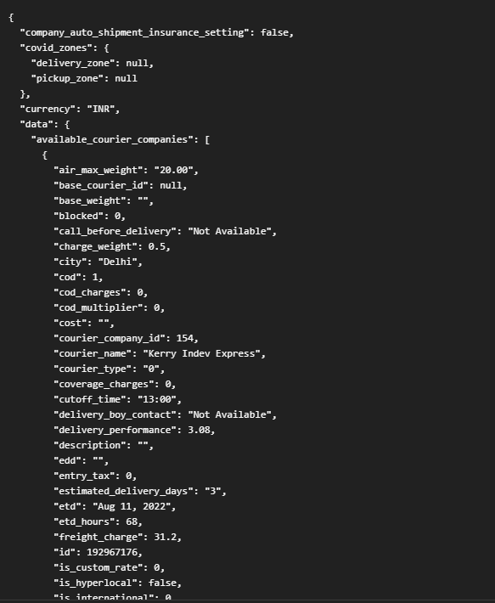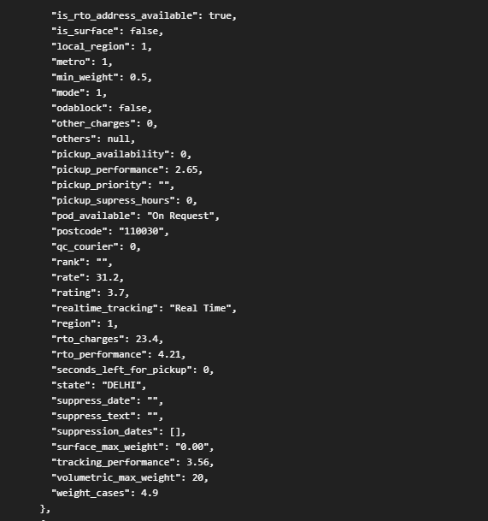



Above is one courier company details out of returned array

1. **Create Order** **(POST)**

**Function-**

**Initial call-**

**Request fields added-**

**Response-**

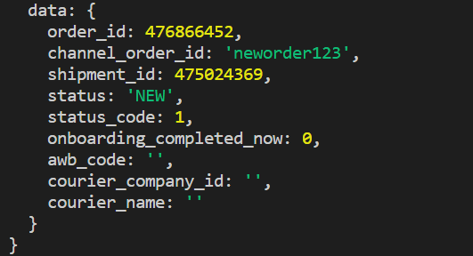

1. **Generate invoice for order**

**Function-** Use this API to generate the invoice for your order by passing the respective Shiprocket order ids.

The generated invoice URL is displayed as a response. Multiple ids can be passed together as an array

**Initial call-**Right after order creation.

**Request fields added-**

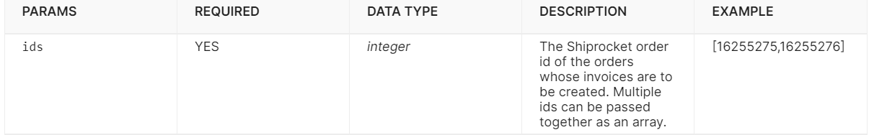

**Response-**

{

"is_invoice_created": true,

"invoice_url": "https://s3-ap-southeast-1.amazonaws.com/kr-shipmultichannel/25149/invoices/KD101019281564656872.pdf",

"not_created": []

}

1. **Generate AWB for shipment**

**Function-** This API can be used to assign the AWB (Air Waybill Number) to your shipment. The AWB is a unique number that helps you track the shipment and get details about it.

**Initial call-** After order creation.

**Request fields added-**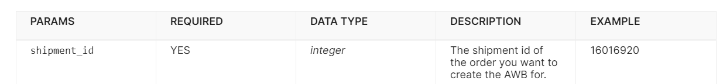

**Response-**{

"awb_assign_status": 1,

"response": {

"data": {

"courier_company_id": 142,

"awb_code": "321055706540",

"cod": 0,

"order_id": 281248157,

"shipment_id": 280640636,

**"awb_code_status": 1**,

"assigned_date_time": {

"date": "2022-11-25 11:17:52.878599",

"timezone_type": 3,

"timezone": "Asia/Kolkata"

},

"applied_weight": 0.5,

"company_id": 25149,

"courier_name": "Amazon Surface",

"child_courier_name": null,

"pickup_scheduled_date": "2022-11-25 14:00:00",

"routing_code": "",

"rto_routing_code": "",

"invoice_no": "retail5769122647118",

"transporter_id": "",

"transporter_name": "",

"shipped_by": {

"shipper_company_name": "manoj",

"shipper_address_1": "Aligarh",

"shipper_address_2": "noida",

"shipper_city": "Jammu",

"shipper_state": "Jammu & Kashmir",

"shipper_country": "India",

"shipper_postcode": "110030",

"shipper_first_mile_activated": 0,

"shipper_phone": "8976967989",

"lat": "32.731899",

"long": "74.860376",

1. **Request shipment Pickup**

**Function-**Use this API to create a pickup request for your order shipment. The API returns the pickup status along with the estimated pickup time.

You will have to call the 'Generate Manifest' API after the successful response of this API.

**Initial call-**After AWB generation, AWB is mandatory for pickup.

**Request fields added-**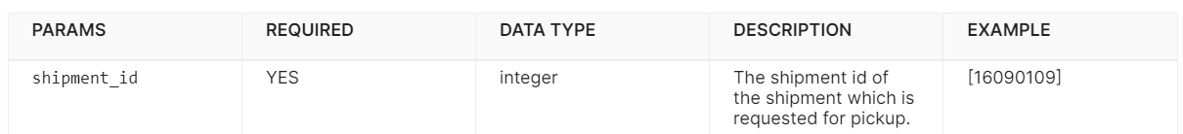

**Response-**

{

"pickup_status": 1,

"response": {

"pickup_scheduled_date": "2021-12-10 12:39:54",

"pickup_token_number": "Reference No: 194_BIGFOOT 1966840_11122021",

"status": 3,

"others": "{\"tier_id\":5,\"etd_zone\":\"z_e\",\"etd_hours\":\"{\\\"assign_to_pick\\\":6.9000000000000004,\\\"pick_to_ship\\\":22.600000000000001,\\\"ship_to_deliver\\\":151.40000000000001,\\\"etd_zone\\\":\\\"z_e\\\",\\\"pick_to_ship_table\\\":\\\"dev_etd_pickup_to_ship\\\",\\\"ship_to_deliver_table\\\":\\\"dev_etd_ship_to_deliver\\\"}\",\"actual_etd\":\"2021-12-18 00:36:03\",\"routing_code\":\"S2\\/S-69\\/1B\\/016\",\"addition_in_etd\":[\"deduction_of_6_and_half_hours\"],\"shipment_metadata\":{\"type\":\"ship\",\"device\":\"WebKit\",\"platform\":\"desktop\",\"client_ip\":\"94.237.77.195\",\"created_at\":\"2021-12-10 12:36:03\",\"request_type\":\"web\"},\"templatized_pricing\":0,\"selected_courier_type\":\"Best in price\",\"recommended_courier_data\":{\"etd\":\"Dec 19, 2021\",\"price\":153,\"rating\":3.6,\"courier_id\":54},\"recommendation_advance_rule\":null,\"dynamic_weight\":\"1.00\"}",

"pickup_generated_date": {

"date": "2021-12-10 12:39:54.034695",

"timezone_type": 3,

"timezone": "Asia/Kolkata"

},

"data": "Pickup is confirmed by Xpressbees 1kg For AWB :- 143254213727423"

}

}

1. **Generate manifest**

**Function-**Using this API, you can generate the manifest for your order. This API generates the manifest and displays the download URL of the same.

Note:

-Multiple ids can also be passed as an array for bulk generation of manifests.

-AWB must be assigned and pickup requested on the shipment id to generate manifest.

**Initial call-**After pickup is scheduled

**Request fields added-**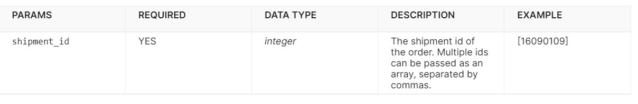

**Response-**

{

"status": 1,

"manifest_url": "https://s3-ap-southeast-1.amazonaws.com/kr-shipmultichannel/25149/manifest/MANIFEST-3051.pdf"

}

1. **Get shipment details**

**Function-**Get the details of a specific Shipment by passing the value of shipment_id in the endpoint URL. No other body parameters are required.

**Initial call-**At any point after pickup scheduling.

**Request fields added-**none.

**Response-**

{

"data": {

"id": 16016920,

"order_id": 16167171,

"channel_id": 76893,

"company_id": 67216,

"invoice_no": null,

"invoice_date": null,

"courier": null,

"sr_courier_id": null,

"awb": null,

"awb_assign_date": null,

"pickup_generated_date": null,

"pickup_token_number": null,

"method": "Standard",

"weight": "0.000",

"dimensions": "0.00x0.00x0.00",

"quantity": 1,

"cost": "0.00",

"tax": "0.00",

"cod_charges": "0.00",

"total": "9000.00",

"shipping_address": {

"city": "New Delhi",

"state": "DELHI",

"address": "House 221B, Leaf Village",

"country": "India",

"pincode": "110002",

"address_2": "Near Hokage House",

"company_name": null

},

"customer_details": null,

"status": 8,

"shipped_date": null,

"delivered_date": null,

"returned_date": null,

"label_url": null,

"manifest_url": null,

"created_at": {

"date": "2019-07-31 12:37:41.000000",

"timezone_type": 3,

"timezone": "Asia/Kolkata"

},

"updated_at": {

"date": "2019-07-31 15:57:11.000000",

"timezone_type": 3,

"timezone": "Asia/Kolkata"

}

}

}

1. **Cancel shipment**

**Function-**Use this API to cancel a created shipment before the "Out for Pickup" state. Multiple AWBs can be passed together as an array to cancel them simultaneously.

**Initial call-**Triggered by vendor at any point when shipment has to be cancelled.

**Request fields added-**

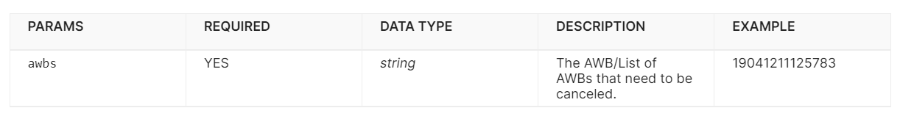

**Response-**

{

"message": "Bulk Shipment cancellation is in progress. Please wait for some time."

}

1. **Create return order**

**Function-**Use this API to create a new return order in your Shiprocket panel. Return orders are created in case the buyer refuses/rejects/returns a specific order.

The parameter specifications are the same as the custom order API, with a few exceptions.

**Initial call-** Called at return event of an order.

**Request fields added-**[**https://apidocs.shiprocket.in/#81b2135b-d43c-4002-8f7f-a670aa5210fa**](https://apidocs.shiprocket.in/#81b2135b-d43c-4002-8f7f-a670aa5210fa)

**Response-**

{

"order_id": 170872392,

"shipment_id": 170411259,

"status": "RETURN PENDING",

"status_code": 21,

"company_name": "shiprocket"

}

1. **Create return AWB**

**Same as AWB generation**

1. **Shipment tracking same as before**